Net 1061 Switching, Routing, and Wireless Essentials

Name:

Lab: #

Follow the instructions down below for the lab itself. For this lab, all answers need to be in blue font. For the questions right below, answer in complete sentences. If this is a self-grading packet tracer. Ensure you paste the screen shot of your score page at the bottom of the document. You will upload both this document and the pkt file regardless if it is self-grading or not. Let the instructor know if you have any questions.

Lab Analysis Report

1. Using complete sentences summarize work you completed during the lab.
In this lab, I first, configured a port on the MLS. Then, I created the VLANs. Then, I configured the virtual interfaces with IP addresses. Then, I configured trunking and enabled routing. Finally, I assigned ipv6 addresses to the interfaces and verified connectivity between the devices.

2. Using complete sentences describe what you learned from the lab. Hint; look at the lab objectives listed at the top of the lab section.
In this lab, I learned how to configure a multi-layer switch. I learned how the process is different than the router-on-a-stick method.

Problems Encountered

1. Using complete sentences describe any problem(s) experienced during lab.
I didn’t experience any problems.

2. Using complete sentences describe how you solved your problem(s).

3. Using complete sentences explain if you needed any assistance with the lab; then list what you learned from that assistance.

Packet Tracer - Configure Layer 3 Switching and Inter-VLAN Routing

Addressing Table
Device | Interface | IP Address / Prefix
MLS | VLAN 10 | 192.168.10.254 /24
MLS | VLAN 10 | 2001:db8:acad:10::1/64
MLS | VLAN 20 | 192.168.20.254 /24
MLS | VLAN 20 | 2001:db8:acad:20::1/64
MLS | VLAN 30 | 192.168.30.254/24
MLS | VLAN 30 | 2001:db8:acad:30::1/64
MLS | VLAN 99 | 192.168.99.254/24
MLS | G0/2 | 209.165.200.225
MLS | G0/2 | 2001:db8:acad:a::1/64
PC0 | NIC | 192.168.10.1
PC1 | NIC | 192.168.20.1
PC2 | NIC | 192.168.30.1
PC3 | NIC | 192.168.10.2/24
PC3 | NIC | 2001:db8:acad:10::2/64
PC4 | NIC | 192.168.20.2/24
PC4 | NIC | 2001:db8:acad:20::2/64
PC5 | NIC | 192.168.30.2
PC5 | NIC | 2001:db8:acad:10::2/64
S1 | VLAN 99 | 192.168.99.1
S2 | VLAN 99 | 192.168.99.2
S3 | VLAN 99 | 192.168.99.3

Objectives
Part 1: Configure Layer 3 Switching
Part 2: Configure Inter-VLAN Routing
Part 3: Configure IPv6 Inter-VLAN Routing

Background / Scenario
A multilayer switch like the Cisco Catalyst 3650 is capable of both Layer 2 switching and Layer 3 routing. One of the advantages of using a multilayer switch is this dual functionality. A benefit for a small to medium-sized company would be the ability to purchase a single multilayer switch instead of separate switching and routing network devices. Capabilities of a multilayer switch include the ability to route from one VLAN to another using multiple switched virtual interfaces (SVIs), as well as the ability to convert a Layer 2 switchport to a Layer 3 interface.

Instructions

Configure Layer 3 Switching
In Part 1, you will configure the GigabitEthernet 0/2 port on switch MLS as a routed port and verify that you can ping another Layer 3 address.
      - On MLS, configure G0/2 as a routed port and assign an IP address according to the Addressing Table.
Open configuration window
MLS(config)# interface g0/2
MLS(config-if)# no switchport
MLS(config-if)# ip address 209.165.200.225 255.255.255.252
      - Verify connectivity to Cloud by pinging 209.165.200.226.
MLS# ping 209.165.200.226

Type escape sequence to abort.
Sending 5, 100-byte ICMP Echos to 209.165.200.226, timeout is 2 seconds:
!!!!!
Success rate is 100 percent (5/5), round-trip min/avg/max = 0/0/0 ms
Close configuration window

Configure Inter-VLAN Routing

Add VLANs.
Open configuration window
Add VLANs to MLS according to the table below. Packet Tracer scoring is case-sensitive, so type the names exactly as shown.
VLAN Number | VLAN Name
10 | Staff
20 | Student
30 | Faculty

Configure SVI on MLS.
Configure and activate the SVI interfaces for VLANs 10, 20, 30, and 99 according to the Addressing Table. The configuration for VLAN 10 is shown below as an example.
MLS(config)# interface vlan 10
MLS(config-if)# ip address 192.168.10.254 255.255.255.0

Configure Trunking on MLS.
Trunk configuration differs slightly on a Layer 3 switch. On the Layer 3 switch, the trunking interface needs to be encapsulated with the dot1q protocol, however it is not necessary to specify VLAN numbers as it is when working with a router and subinterfaces.
      - On MLS, configure interface g0/1.
      - Make the interface a static trunk port.
MLS(config-if)# switchport mode trunk
      - Specify the native VLAN as 99.
MLS(config-if)# switchport trunk native vlan 99
      - Encapsulate the link with the dot1q protocol.
MLS(config-if)# switchport trunk encapsulation dot1q
Note: Packet Tracer may not score the trunk encapsulation.

Configure trunking on S1.
      - Configure interface g0/1 of S1 as a static trunk.
      - Configure the native VLAN on the trunk.

Enable routing.

Question:
      - Use the show ip route command. Are there any active routes?
No, there are no active routes.
Type your answers here.
      - Enter the ip routing command to enable routing in global configuration mode.
MLS(config)# ip routing
      - Use the show ip route command to verify routing is enabled.
MLS# show ip route
Codes: C - connected, S - static, I - IGRP, R - RIP, M - mobile, B - BGP
D - EIGRP, EX - EIGRP external, O - OSPF, IA - OSPF inter area
N1 - OSPF NSSA external type 1, N2 - OSPF NSSA external type 2
E1 - OSPF external type 1, E2 - OSPF external type 2, E - EGP
i - IS-IS, L1 - IS-IS level-1, L2 - IS-IS level-2, ia - IS-IS inter area
* - candidate default, U - per-user static route, o - ODR
P - periodic downloaded static route

Gateway of last resort is not set

C 192.168.10.0/24 is directly connected, Vlan10
C 192.168.20.0/24 is directly connected, Vlan20
C 192.168.30.0/24 is directly connected, Vlan30
C 192.168.99.0/24 is directly connected, Vlan99
209.165.200.0/30 is subnetted, 1 subnets
C 209.165.200.224 is directly connected, GigabitEthernet0/2
Close configuration window

Verify end-to-end connectivity.
      - From PC0, ping PC3 or MLS to verify connectivity within VLAN 10.
      - From PC1, ping PC4 or MLS to verify connectivity within VLAN 20.
      - From PC2, ping PC5 or MLS to verify connectivity within VLAN 30.
      - From S1, ping S2, S3, or MLS to verify connectivity with VLAN 99.
      - To verify inter-VLAN routing, ping devices outside the sender’s VLAN.
      - From any device, ping this address inside Cloud, 209.165.200.226.
The Layer 3 switch is now routing between VLANs and providing routed connectivity to the cloud.

Configure IPv6 Inter-VLAN Routing
Layer 3 switches also route between IPv6 networks.

Enable IPv6 routing.
Open configuration window
Enter the ipv6 unicast-routing command to enable IPv6 routing in global configuration mode.
MLS(config)# ipv6 unicast-routing

Configure SVI for IPv6 on MLS.
Configure IPv6 addressing on SVI for VLANs 10, 20, and 30 according to the Addressing Table. The configuration for VLAN 10 is shown below.
MLS(config)# interface vlan 10
MLS(config-if)# ipv6 address 2001:db8:acad:10::1/64

Configure G0/2 with IPv6 on MLS.
      - Configure IPv6 addressing on G0/2.
MLS(config)# interface G0/2
MLS(config-if)# ipv6 address 2001:db8:acad:a::1/64
      - Use the show ipv6 route command to verify IPv6 connected networks.
MLS# show ipv6 route
IPv6 Routing Table - 10 entries
Codes: C - Connected, L - Local, S - Static, R - RIP, B - BGP
U - Per-user Static route, M - MIPv6
I1 - ISIS L1, I2 - ISIS L2, IA - ISIS interarea, IS - ISIS summary
O - OSPF intra, OI - OSPF inter, OE1 - OSPF ext 1, OE2 - OSPF ext 2
ON1 - OSPF NSSA ext 1, ON2 - OSPF NSSA ext 2
D - EIGRP, EX - EIGRP external
S ::/0 [1/0]
via 2001:DB8:ACAD:A::2, GigabitEthernet0/2
C 2001:DB8:ACAD:A::/64 [0/0]
via ::, GigabitEthernet0/2
L 2001:DB8:ACAD:A::1/128 [0/0]
via ::, GigabitEthernet0/2
C 2001:DB8:ACAD:10::/64 [0/0]
via ::, Vlan10
L 2001:DB8:ACAD:10::1/128 [0/0]
via ::, Vlan10
C 2001:DB8:ACAD:20::/64 [0/0]
via ::, Vlan20
L 2001:DB8:ACAD:20::1/128 [0/0]
via ::, Vlan20
C 2001:DB8:ACAD:30::/64 [0/0]
via ::, Vlan30
L 2001:DB8:ACAD:30::1/128 [0/0]
via ::, Vlan30
L FF00::/8 [0/0]
via ::, Null0
Close configuration window

Verify IPv6 connectivity.
Devices PC3, PC4, and PC5 have been configured with IPv6 addresses. Verify IPv6 inter-VLAN routing and connectivity to Cloud.
      - From PC3, ping MLS to verify connectivity within VLAN 10.
      - From PC4, ping MLS to verify connectivity within VLAN 20.
      - From PC5, ping MLS to verify connectivity within VLAN 30.
      - To verify inter-VLAN routing, ping between devices PC3, PC4, and PC5.
      - From PC3 ping the address inside Cloud, 2001:db8:acad:a::2.
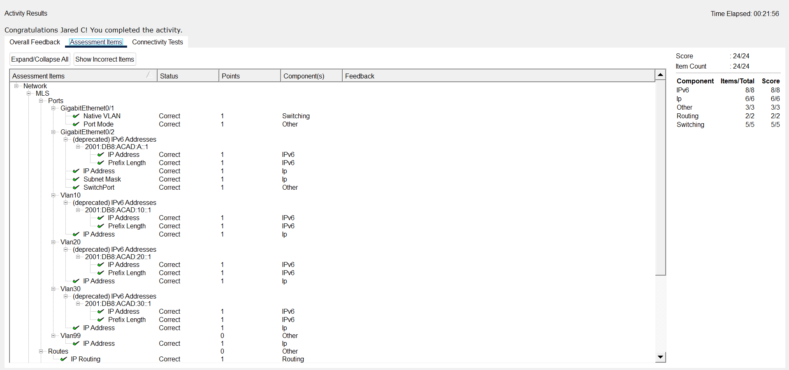
End of document

